**Progress Report - Security Posture & Risk Assessment**

**Technical Progress Since the Start of the Project**

Since the project began, our team has focused on preparing for the interview phase. We have collectively developed a comprehensive interview questionnaire to assess the company’s current security posture and risk management practices. Each team member contributed to creating different set of the questionnaire:

Mian Fazal Ur Rehman contributed to drafting questions about.

* General IT & Security Questions
* Shadow IT & Unauthorized Applications
* Network & Data Security
* Identity & Access Management (IAM)
* Incident Response & Compliance
* Recommendations & Security Improvements

Shihan Deshapriya Navimana Vidanage contributed to drafting questions about.

* Security Governance & Leadership
* Third-Party & Supply Chain Security
* Security Metrics & Performance Monitoring
* Insider Threat Management
* Cloud & Emerging Technologies Security
* Backup & Disaster Recovery
* Compliance & Legal Considerations
* Security Culture & Employee Engagement

Sushila Karmacharya added some more questions related to

* Security Awareness & Training
* Remote Work & Mobile Device Security
* Software & Patch Management
* Firewall Configuration
* Network Architecture & Design

Theofill Jake Gepila Bautista identified a company to interview and reached out via email to request a session. The company has since responded positively and confirmed their willingness to participate. We are now finalizing details to proceed with the next steps for the interview.

**Email requested for the interview**

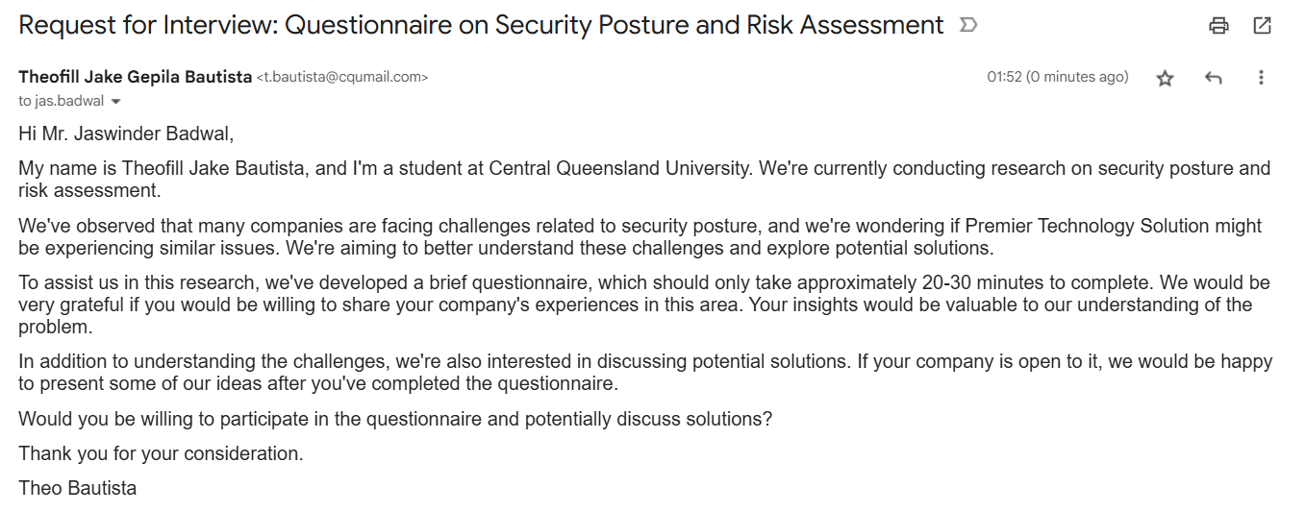

**Response from the company**

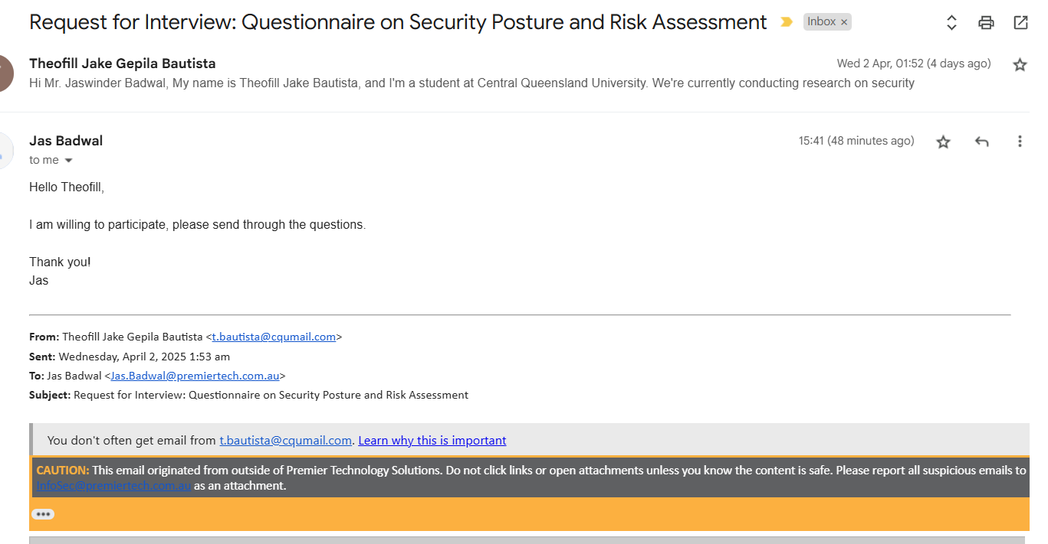

**2. Status of Tasks Completed & Changes to Project Plan**

Completed:

* Prepare set of the interview questionnaire.
* Sent out the interview request email to the company.
* Got response from the company for the interview.

**3. Issues and Challenges**

Delays in Response from the Company: We have waited for the response for a while to schedule the interview. This has caused a slight delay in moving forward with the project.

Ensuring Question Relevance: We wanted to ensure the interview questions are clear and applicable to the company.

**4. Priority Tasks for the Next Phase**

* Finalize the set of interview questions by selecting the most relevant questions from the questions collected by all the members.
* Schedule and conduct the interview with the company.
* Document the results of the interview and begin drafting the initial risk assessment based on the responses received.
* Identify potential vulnerabilities and security gaps based on the interview data.
* Begin developing the risk mitigation strategies tailored to the company’s specific needs.